

**Unlock the Experience Now**

**Where to start:**

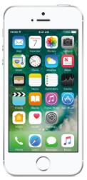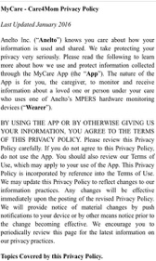

**2**

**Accept Agreement**

Read and accept agreement by pressing “I Agree” on top right of phone screen

**Create Your Account**

Upon launching the app, click “Create Account” and fill in the requested information: name, phone number, home address, email, and select the password you would like to use.

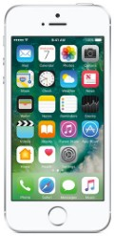

**1**

**Account Number**

Input the account number, the alphanumeric code found on the back of the handheld device and charger, then click “Register”

Note: You must be previously registered as an emergency contact on the account to gain access to the RemoteCare 247 app. This should have been done at the time of setup. If you need assistance, please contact your dealer.

**3**

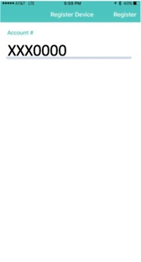

After downloading the app, just follow these instructions to access your new app so you can start getting the most out of your **Caregiver Tool Kit**



Download the **RemoteCare247** app on

Google Play (Android) or the Apple Store (iPhone)